A Project report on

Future of Loan Approvals with Explainable AI

A Dissertation submitted to JNTU Hyderabad in partial fulfillment of the academic requirements for the award of the degree.

Bachelor of Technology
in
Computer Science and Engineering (AI&ML)
Submitted by

YERICHARLA AAKASH
(23H51A66T7)
CHINMAI REDDY SANAM
(23H51A66W4)
VADLA VISHNU VARDHAN CHARI
(24H55A6637)

Under the esteemed guidance of
Mr. D. Ranadeep Reddy
(Assistant Professor)


Department of Computer Science and Engineering (AI&ML)

CMR COLLEGE OF ENGINEERING & TECHNOLOGY

(UGC Autonomous)
*Approved by AICTE *Affiliated to JNTUH *NAAC Accredited with A⁺ Grade

KANDLAKOYA, MEDCHAL ROAD, HYDERABAD - 501401.

2024- 2025

CMR COLLEGE OF ENGINEERING & TECHNOLOGY
KANDLAKOYA, MEDCHAL ROAD, HYDERABAD – 501401

DEPARTMENT OF COMPUTER SCIENCE AND ENGINEERING(AI&ML)


CERTIFICATE

This is to certify that the Major Project report entitled “Future of Loan Approvals with Explainable AI” being submitted by Yericharla Aakash (23H5166T7), Chinmai Reddy Sanam (23H51A66W4), Vadla Vishnu Vardhan Chari (24H55A6637), in partial fulfillment for the award of Bachelor of Technology in Computer Science and Engineering(AI&ML) is a record of bonafide work carried out his/her under my guidance and supervision.

The results embodies in this project report have not been submitted to any other University or Institute for the award of any Degree.

Mr. D. Ranadeep Reddy Dr. S.Kirubakaran EXTERNAL EXAMINER
Assistant Professor Professor and HOD
Dept. of CSE(AI&ML) Dept. of CSE(AI&ML)-II

ACKNOWLEDGEMENT

With great pleasure we want to take this opportunity to express my heartfelt gratitude to all the people who helped in making this project work a grand success.
We are grateful to Mr. D. Ranadeep Reddy, Assistant Professor, Department of Computer Science and Engineering (AI&ML) for his valuable technical suggestions and guidance during the execution of this project work.
We would like to thank Dr. S.KIRUBAKARAN , Head of the Department of Computer Science and Engineering (AI&ML)-II, CMR College of Engineering & Technology, who is the major driving forces to complete my project work successfully.
We are very grateful to Dr. Ghanta Devadasu, Dean-Academics, CMR College of Engineering & Technology, for his constant support and motivation in carrying out the project work successfully.
We extend our heartfelt gratitude to Dr. Seshu Kumar Avadhanam, Principal, CMR College of Engineering & Technology, for his unwavering support and guidance in the successful completion of our project and his encouragement has been invaluable throughout this endeavor.
We are highly indebted to Major Dr. V A Narayana, Director, CMR College of Engineering & Technology, for giving permission to carry out this project in a successful and fruitful way.
We express our sincere thanks to Shri. Ch. Gopal Reddy, Secretary & Correspondent, CMR Group of Institutions, and Shri Ch Abhinav Reddy, CEO, CMR Group of Institutions for their continuous care and support.
We would like to thank the Teaching & Non- teaching staff of Department of Computer Science & Engineering for their co-operation.
Finally, we extend thanks to our parents who stood behind us at different stages of this Project. We sincerely acknowledge and thank all those who gave support directly and indirectly in completion of this project work.

Yericharla Aakash 23H51A66T7
Chinmai Reddy Sanam 23H51A66W4
Vadla Vishnu Vardhan Chari 24H55A6637
Future of Loan Approvals with Explainable AI

DECLARATION
We hereby declare that results embodied in this Report of Real Time Project on “Future of Loan Approvals with Explainable AI” are from work carried out by using partial fulfillment of the requirements for the award of Bachelor of Technology in Computer Science and Engineering (AI&ML). We have not submitted this report to any other university/institute for the award of any other degree.

NAME ROLL NO SIGNATURE
YERICHARLA AAKASH 23H51A66T7
CHINMAI REDDY SANAM 23H51A66W4
VADLA VISHNU VARDHAN CHARI 24H55A6637

Future of Loan Approvals with Explainable AI

TABLE OF CONTENTS

CHAPTER
NO. TITLE PAGE NO.
LIST OF FIGURES ii
ABSTRACT iii
1 INTRODUCTION 1
1.1 Problem Statement 2
1.2 Research Objective 2
1.3 Project Scope and Limitations 3
2 BACKGROUND WORK 4
2.1. AI-Based Credit Scoring Models 5
2.1.1.Introduction 5
2.1.2.Merits,Demerits and Challenges 5
2.1.3.Implementation of AI-Based Credit Scoring Models 5
2.2. Traditional Loan Approval Systems 6
2.2.1.Introduction 6
2.2.2.Merits,Demerits and Challenges 6
2.2.3.Implementation of Traditional Loan Approval Systems 6
2.3. Explainable AI in Loan Approvals 7
2.3.1.Introduction 7
2.3.2.Merits,Demerits and Challenges 7
2.3.3.Implementation of Explainable AI in Loan Approvals 7
3 PROPOSED SYSTEM 8
3.1. Research Objective of Proposed Model 9
3.2. Algorithms Used for Proposed Model 9
3.3. Designing 10
3.3.1.UML Diagram 10
3.3. Stepwise Implementation and Code 13
4 RESULTS AND DISCUSSION 16 4.1. Performance metrics 17
5 CONCLUSION 22
5.1 Conclusion and Future Enhancement 23
REFERENCES 24
Publication Details 25
GitHub Link 26

CMRCET CSE(AI&ML) Page No i

Future of Loan Approvals with Explainable AI

List of Figures

FIGURE NO. | TITLE | PAGE NO.
3.1 | UseCase diagram | 12
3.2 | Class Diagram | 13
3.3 | Sequence Diagram | 14
3.4 | Collaboration Diagram | 15
4.1 | Interface | 20
4.2 | Loan Application Dataset | 20
4.3 | Graph for Loan and Reject Reason | 21
4.4 | Numeric Format | 21
4.5 | Split Dataset Train and Test | 22
4.6 | Trim AI on Loan Approval Status | 22
4.7 | Trim AI on Rejection Reason | 23
4.8 | Explainable AI Feature Contribution | 23
4.9 | Predict Loan Status using Test Data | 24
4.10 | Predict Output | 24
4.11 | Predicted Loan Status with Reason | 25

CMRCET CSE(AI&ML) Page No ii
Future of Loan Approvals with Explainable AI

ABSTRACT

The project titled “Future of Loan Approvals with Explainable AI” explores the integration of Explainable Artificial Intelligence (XAI) into the loan approval process to address the increasing demand for transparency, fairness, and accountability in financial decision-making. Traditional AI models often function as black boxes, providing little to no insight into how decisions are made, which raises concerns related to bias, discrimination, and lack of trust. This project proposes a system that not only evaluates an applicant's creditworthiness but also explains the rationale behind each decision using techniques such as SHAP (SHapley Additive exPlanations) and LIME (Local Interpretable Model-Agnostic Explanations).
By offering interpretable and justifiable results, the system enhances user confidence, regulatory compliance, and ethical AI practices. It also incorporates adaptability to changing economic and regulatory conditions, making it robust and future-ready. The final outcome of this project is to design a user-centric AI framework for loan approvals that balances predictive accuracy with interpretability, thereby fostering a more inclusive and trustworthy lending environment.

CMRCET CSE(AI&ML) Page No iii
Future of Loan Approvals with Explainable AI

CHAPTER 1
INTRODUCTION

CMRCET CSE(AI&ML) Page No 1
Future of Loan Approvals with Explainable AI

CHAPTER 1
INTRODUCTION
1.1.Problem Statement
Loan approval systems in financial institutions often rely on complex AI models that lack transparency and interpretability. Applicants are typically unaware of the exact reasons for their loan approval or rejection, leading to dissatisfaction, confusion, and diminished trust in automated decision-making systems. These black-box models can also unknowingly reinforce bias based on demographic or socioeconomic factors.
Despite regulatory efforts and internal audits, many financial institutions struggle to ensure fairness and explainability in lending decisions. Traditional systems fail to provide understandable feedback to applicants or satisfy growing regulatory demands. There is a pressing need for a transparent, trustworthy, and fair AI-driven system that supports accurate decision-making while providing human-understandable justifications. This project addresses the problem by proposing an Explainable AI-based loan approval system that enhances clarity, mitigates bias, and improves trust in AI decisions.
1.2.Research Objective
The primary objective of this project is to improve transparency and trust in automated loan approval systems by developing an Explainable AI (XAI) framework capable of delivering clear, human-understandable justifications for decisions. The system aims to go beyond traditional black-box AI models by integrating techniques that provide insights into how individual features influence loan approval outcomes.
This approach ensures that applicants and financial institutions alike can interpret and validate the reasoning behind approval or rejection. The project explores model-agnostic and interpretable AI methods to support fairness, accountability, and regulatory compliance. By implementing the solution in a practical environment using Python and modern visualization tools, the project demonstrates the feasibility of deploying explainable models in real-world banking systems. Ultimately, the research aspires to bridge the gap between AI accuracy and decision transparency in financial services.

CMRCET CSE(AI&ML) Page No 2

Future of Loan Approvals with Explainable AI

1.3 Project Scope and Limitations

Scope:
The scope of this project is to design and implement an Explainable AI (XAI) system that enhances the transparency and trustworthiness of loan approval processes in financial institutions. The project emphasizes building a framework that not only predicts loan outcomes but also provides clear, interpretable explanations for each decision using visual and textual insights. The focus is on using model-agnostic techniques such as SHAP or LIME to highlight how specific input features—such as income, credit score, and employment history—influence the decision.
The solution will be demonstrated through a Python-based prototype, showcasing its feasibility in a real-world financial context. It aims to create a balance between accuracy and interpretability while ensuring ease of understanding for both end users and bank officials. The project considers the practical application of such systems in modern banking infrastructure, with a focus on user trust, compliance, and decision accountability.
Limitations:
- The system does not make actual financial decisions; it only provides explainable insights based on input data.
- The project does not cover data privacy or legal implications involved in AI-based loan processing.
- Accuracy and explanations are highly dependent on the quality and relevance of the input dataset used.
- The approach may not scale efficiently to very large datasets or high-frequency real-time processing environments.
- Integration with existing legacy banking systems may require extensive customization and validation.

CMRCET CSE(AI&ML) Page No 3

Future of Loan Approvals with Explainable AI

CHAPTER 2
BACKGROUND WORK

CMRCET CSE(AI&ML) Page No 4

Future of Loan Approvals with Explainable AI

CHAPTER 2
BACKGROUND WORK
2.1. Traditional Loan Approval Systems

2.1.1. Introduction

Traditional loan approval systems rely on manual assessment and credit scoring models to evaluate borrower eligibility. These systems primarily use historical financial data, credit scores, and income verification to decide loan approvals. While effective in maintaining risk management, they often lack transparency, making it difficult for applicants to understand why their loans were accepted or denied. The reliance on static rules and historical patterns means that unconventional borrowers, such as freelancers or small business owners, may struggle to secure loans due to non-traditional income structures.

2.1.2. Merits
- Traditional models provide consistency in credit evaluation, ensuring standardized lending practices across financial institutions.

Manual verification of credit history reduces reliance on complex algorithms, making decision-making straightforward.

Demerits
- The rigid nature of traditional approval processes prevents flexibility in assessing borrowers outside conventional criteria, potentially excluding those with unconventional income streams.
- Decisions are often difficult to challenge or interpret, leaving applicants unaware of specific reasons behind rejections.

Challenges

Ensuring fairness and transparency in loan approvals is challenging, especially for applicants with limited financial history. AI models must mitigate biases from past lending practices while adapting to regulatory changes and economic fluctuations. Fraudulent applications and identity theft pose risks, requiring robust verification methods.

CMRCET CSE(AI&ML) Page No 5
Future of Loan Approvals with Explainable AI

Borrowers may struggle to interpret AI-driven decisions, leading to concerns about trust. Institutions must ensure AI-generated

\explanations are clear and compliant. Regulatory bodies demand accountability in loan processing, adding complexity to AI model deployment. Balancing automation with ethical decision-making remains a critical challenge.

2.1.3. Implementation of Explainable AI

Explainable AI improves loan approvals by generating interpretable explanations for decisions. SHAP and LIME identify influential factors, clarifying outcomes. Borrowers receive transparency regarding approval status and rejection causes. AI models process financial behavior, risk assessments, and past credit trends to provide explanations. Implementation involves fairness-aware techniques to minimize biases. Visual dashboards display key decision metrics for stakeholders. AI models depend on high-quality data and adaptive learning mechanisms for accuracy. Despite benefits, ensuring explainability across diverse borrower profiles remains complex. Continuous optimization is essential for maintaining fairness and trust in loan approvals.

CMRCET CSE(AI&ML) Page No 6

Future of Loan Approvals with Explainable AI
2.2. Explainable AI in Loan Approvals

2.2.1. Introduction

Explainable AI (XAI) is designed to bring transparency to AI-driven loan approvals by offering clear justifications for decisions. Traditional AI models act as "black boxes," where predictions are made but the reasoning remains unclear. With XAI, loan applicants and financial institutions can understand the factors behind approval or rejection, improving trust and regulatory compliance. XAI techniques such as SHAP and LIME help break down complex AI models into interpretable explanations, ensuring users grasp how creditworthiness is determined.

2.2.2. Merits

Enhances trust between borrowers and lenders by providing transparency in loan decisions.

Helps financial institutions identify biases in their models, ensuring fairer lending practices.

Demerits
- Opaque decision-making in AI models makes explanations difficult.
- Risk of biased predictions if training data is imbalanced.
- Regulatory challenges in ensuring fairness and accountability.

Challenges

Maintaining interpretability in AI-driven lending systems.

Ensuring compliance with ethical AI guidelines.

Preventing biases in automated decision-making to ensure fairness.

2.2.3. Implementation of AI-Based Credit Scoring Models

AI-driven credit scoring models use techniques such as neural networks, decision trees, and gradient boosting algorithms to predict loan approvals. These models analyze large datasets to classify borrowers based on risk profiles, adjusting dynamically to financial trends. However, due to the black-box nature of many AI algorithms, financial institutions face challenges in explaining decisions to borrowers and regulatory authorities.

CMRCET CSE(AI&ML) Page No 7
Future of Loan Approvals with Explainable AI

2.3 Explainable AI in Loan Approvals
2.3.1 Introduction
Explainable Artificial Intelligence (XAI) refers to a set of processes and methods that allow human users to understand and trust the output of machine learning algorithms. In the context of loan approvals, XAI helps make the decision-making process of AI systems transparent by explaining why a particular application was accepted or rejected. This is particularly important in the financial domain, where decisions must comply with regulatory standards and be fair, accountable, and understandable by both users and regulatory bodies.
By incorporating XAI into loan approval systems, banks and financial institutions can provide applicants with a reason behind every decision, thereby improving customer trust and reducing dissatisfaction.
2.3.2 Merits, Demerits and Challenges
Merits:
- Transparency: Users and loan officers can see which features (like income, credit score) influenced the decision.
- Trust and Accountability: Builds trust between users and institutions by providing clear explanations.
- Regulatory Compliance: Helps meet regulations such as GDPR or RBI norms that require explainability in automated decisions.
- Debugging and Optimization: Developers can understand model behavior and improve it based on insights from explanations.
Demerits:
- Complexity: Implementing explainability adds another layer of development complexity.
- Performance Trade-offs: Some highly accurate models (like deep learning) are inherently "black boxes" and may need to be simplified for explainability.
- Information Overload: Too much explanation or technical detail can overwhelm non-technical users.
Challenges:
- Balancing Accuracy and Interpretability: It's often hard to find models that are both highly accurate and easily interpretable.

CMRCET CSE(AI&ML) Page No 8

Future of Loan Approvals with Explainable AI

- Model-Specific vs. Model-Agnostic Explanations: Choosing the right explainability method can be difficult depending on the model used.
- User Understanding: Ensuring that explanations are meaningful and understandable to the target audience (e.g., loan applicants).

2.3.3 Implementation of Explainable AI in Loan Approvals
The implementation of Explainable AI in loan approvals typically involves the integration of explanation techniques with predictive models. Popular model-agnostic tools like SHAP (SHapley Additive exPlanations) and LIME (Local Interpretable Model-Agnostic Explanations) are used to interpret predictions from complex models.
For example:
- SHAP values break down each prediction to show how much each input feature contributed to the final output.
- LIME approximates the behavior of a complex model locally with an interpretable one (like linear regression) to explain individual predictions.
In this project, SHAP is used to analyze how features such as loan amount, applicant income, credit history, and employment status affect loan approval predictions. These visual and textual explanations are presented alongside predictions to provide transparency for both end-users and financial institutions.

CMRCET CSE(AI&ML) Page No 9

Future of Loan Approvals with Explainable AI

CHAPTER 3
PROPOSED SYSTEM

CMRCET CSE (AI&ML) Page No 10
Future of Loan Approvals with Explainable AI

3.1 Research Objective
The objective of this project is to design and implement an AI-driven loan approval system that integrates explainable artificial intelligence (XAI) to enhance transparency, trust, and fairness in financial decision-making. Traditional loan approval processes often suffer from bias, lack of clarity, and inefficiencies, while AI systems, although accurate, are frequently criticized for their “black-box” nature, which makes their decisions difficult to interpret.
To address this, the proposed system combines predictive machine learning models with explanation frameworks like SHAP (SHapley Additive exPlanations), allowing stakeholders to understand why a particular loan application was approved or rejected. This dual focus ensures that decisions are both accurate and interpretable, supporting regulatory compliance and ethical AI practices.
The implementation is carried out using the Django web framework and integrated with Python-based machine learning libraries. The system is designed to be scalable, user-friendly, and suitable for deployment in real-world financial institutions. Ultimately, this research aims to contribute to a future where automated financial systems are not only intelligent but also accountable and transparent.

3.2 Algorithms Used

- LIME (Local Interpretable Model-Agnostic Explanations)
  - Provides local explanations by approximating the model with an interpretable one (e.g., linear regression) around the prediction.
  - Explains why a particular prediction was made.
- SHAP (SHapley Additive exPlanations)
  - Based on cooperative game theory (Shapley values).
  - Shows how each feature contributes positively or negatively to the prediction.
  - Supports both global (overall model) and local (individual predictions) explainability.

CMRCET CSE(AI&ML) age No 11

Future of Loan Approvals with Explainable AI

3.3. Designing
3.3.1 UML Diagrams

USE CASE DIAGRAM:
A use case diagram in the Unified Modeling Language (UML) is a type of behavioral diagram defined by and created from a Use-case analysis. Its purpose is to present a graphical overview of the functionality provided by a system in terms of actors, their goals (represented as use cases), and any dependencies between those use cases. The main purpose of a use case diagram is to show what system functions are performed for which actor. Roles of the actors in the system can be depicted.

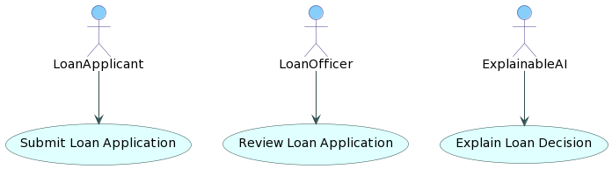

Fig 3.1: UseCase Diagram

CMRCET CSE(AI&ML) Page No 12

Future of Loan Approvals with Explainable AI

CLASS DIAGRAM:

In software engineering, a class diagram in the Unified Modeling Language (UML) is a type of static structure diagram that describes the structure of a system by showing the system's classes, their attributes, operations (or methods), and the relationships among the classes. It explains which class contains information.

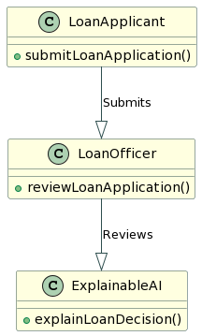

Fig 3.2: Class Diagram

CMRCET CSE(AI&ML) Page No 13

Future of Loan Approvals with Explainable AI

SEQUENCE DIAGRAM:

A sequence diagram in Unified Modeling Language (UML) is a kind of interaction diagram that shows how processes operate with one another and in what order. It is a construct of a Message Sequence Chart. Sequence diagrams are sometimes called event diagrams, event scenarios, and timing diagrams.

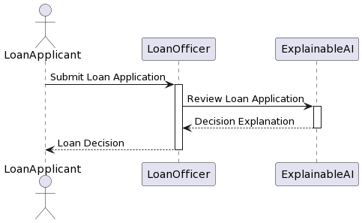

Fig 3.3: Sequence Diagram

CMRCET CSE(AI&ML) Page No 14

Future of Loan Approvals with Explainable AI

COLLABORATION DIAGRAM:

Activity diagrams are graphical representations of workflows of stepwise activities and actions with support for choice, iteration and concurrency. In the Unified Modeling Language, activity diagrams can be used to describe the business and operational step-by-step workflows of components in a system. An activity diagram shows the overall flow of control.

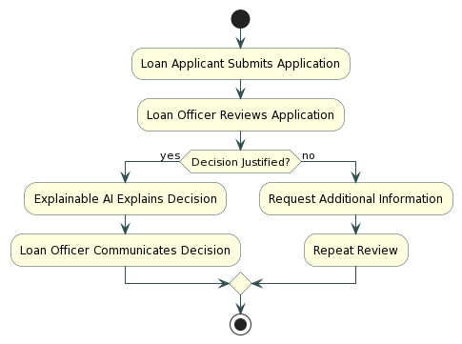

Fig 3.4: Collaboration Diagram

CMRCET CSE(AI&ML) Page No 15

Future of Loan Approvals with Explainable AI

3.4. Stepwise Implementation and Code

IMPLEMENTATION:

MODULES:
1. Upload Historical Trajectory Dataset : Upload Historical Trajectory Dataset’ button and upload dataset.
2. Generate Train & Test Model :Generate Train & Test Model’ button to read dataset and to split dataset into train and test part to generate machine learning train model
3. Run MLP Algorithm:Run MLP Algorithm’ button to train MLP model and to calculate its accuracy.
4. Run DDS with Genetic Algorithm : Run DDS with Genetic Algorithm button to train DDS and to calculate its prediction accuracy.
5. Predict DDS Type :Predict DDS Type’ button to predict test data

CMRCET CSE(AI&ML) Page No 16
Future of Loan Approvals with Explainable AI

CHAPTER 4
RESULTS AND DISCUSSION

CMRCET CSE(AI&ML) Page No 17

Future of Loan Approvals with Explainable AI
CHAPTER 4
RESULTS AND DISCUSSION
4.1. Performance Metrics
Performance metrics are essential to evaluate the effectiveness of the loan approval prediction model and its explainability. These metrics provide quantitative measures of how well the machine learning model performs in classifying loan applications accurately while ensuring transparency and fairness in decision-making.
Accuracy
- Accuracy measures the overall correctness of the model’s predictions. It is calculated as the ratio of correct predictions to the total number of predictions.
- In the context of loan approvals, accuracy reflects how well the model identifies approved and rejected applications compared to the actual outcomes.
Precision
- Precision indicates the proportion of correctly predicted positive loan approvals out of all predicted positive approvals.
- High precision is crucial to avoid falsely approving risky loan applications, which could result in financial loss.
Recall
- Recall (or sensitivity) is the ability of the model to correctly identify all actual approved loan cases.
- It ensures that eligible applicants are not wrongly denied, thereby maintaining fairness in the approval process.
F1-Score
- F1-score is the harmonic mean of precision and recall, providing a balance between them.

CMRCET CSE(AI&ML) Page No 18
Future of Loan Approvals with Explainable AI

- It is particularly useful when there is an imbalance in the dataset between approved and rejected loan cases.
AUC-ROC Curve
- The Area Under the Receiver Operating Characteristic (AUC-ROC) curve evaluates the model’s ability to distinguish between classes.
- A higher AUC value implies better discrimination between approved and rejected loan applications.
Explainability Metrics
- In addition to predictive accuracy, the model's interpretability is assessed using explainability techniques like SHAP (SHapley Additive exPlanations) and LIME.
- These tools provide insight into which features most influence the decision, supporting transparency and user trust in the system.

CMRCET CSE(AI&ML) Page No 19
Future of Loan Approvals with Explainable AI

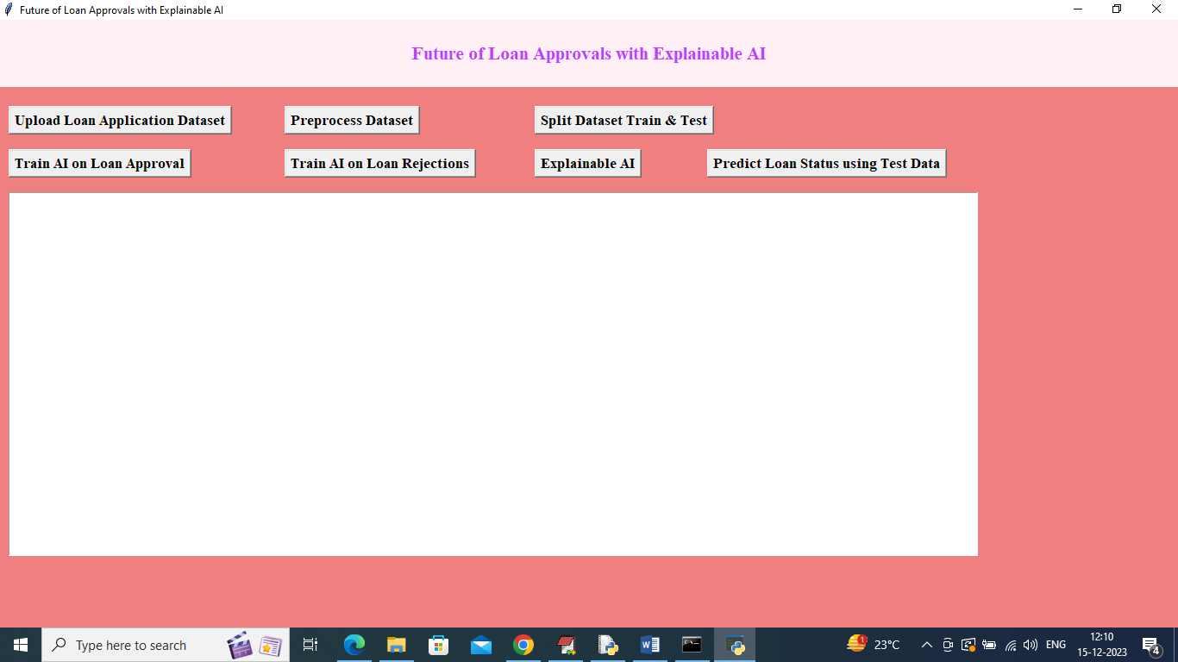

Fig 4.1: Interface

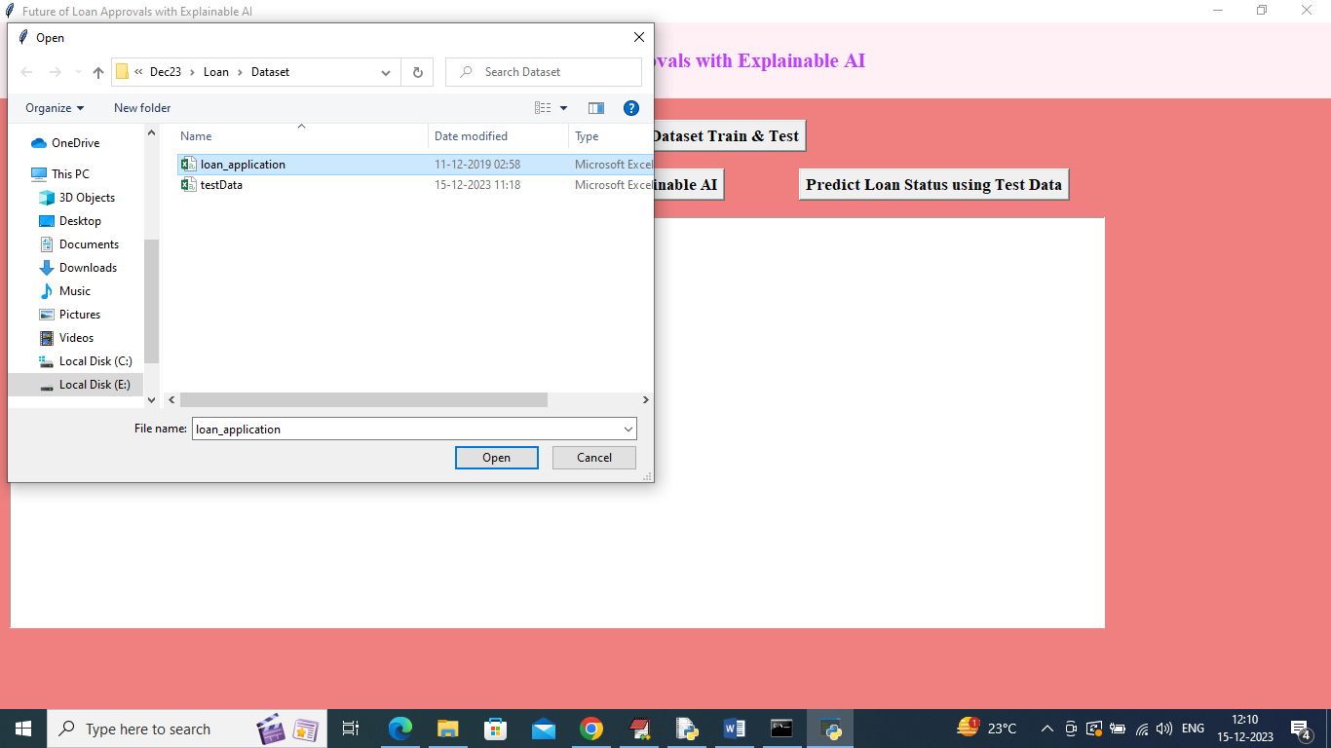

Fig 4.2: Upload ‘loan_application.csv’ dataset

CMRCET CSE(AI&ML) Page No 20
Future of Loan Approvals with Explainable AI

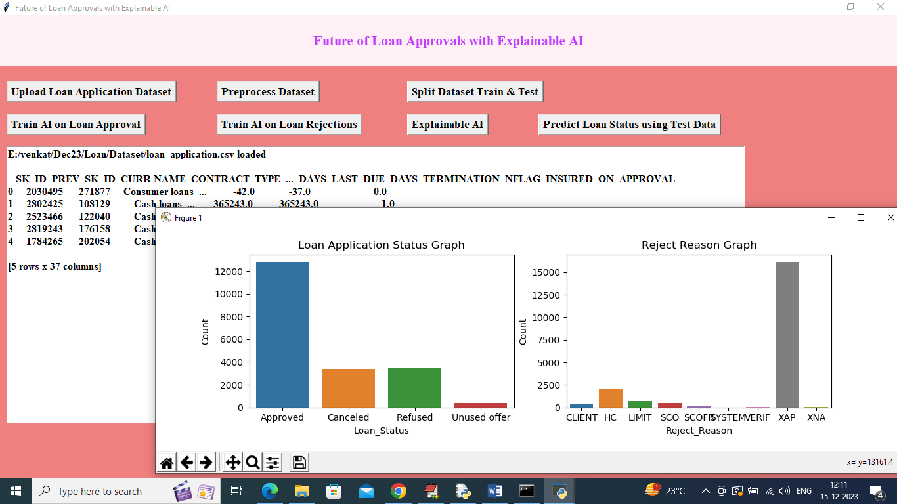

Fig 4.3: Dataset Uploaded and Graph for Loan and Reject Reason

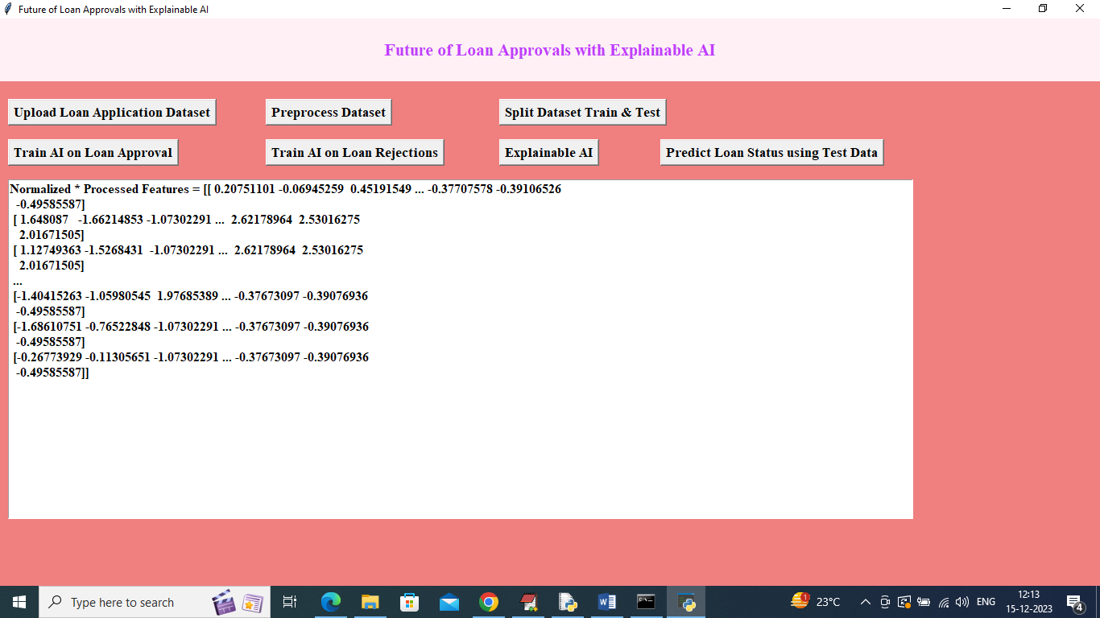

Fig 4.4: Dataset Converted to Numeric Format

CMRCET CSE(AI&ML) Page No 21
Future of Loan Approvals with Explainable AI

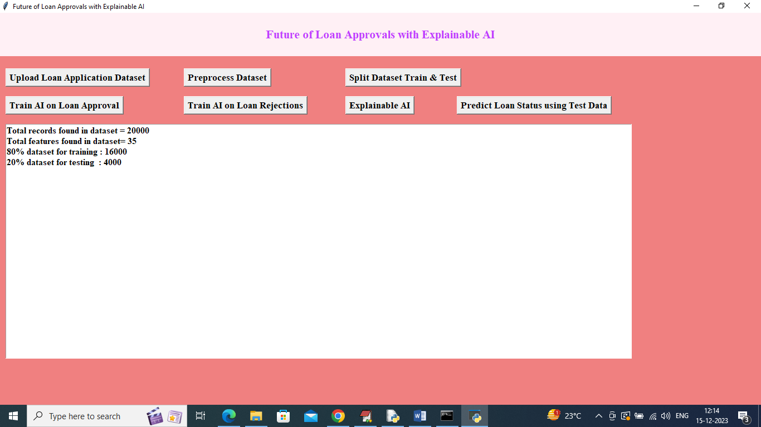

Fig 4.5: Split Dataset Train and Test

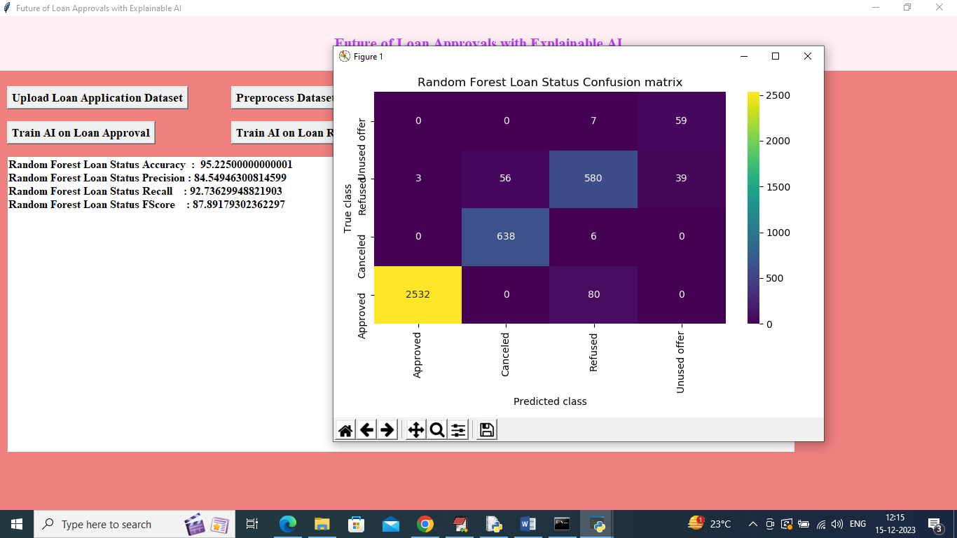

Fig 4.6: Train AI on Loan Approval Status

CMRCET CSE(AI&ML) Page No 22

Future of Loan Approvals with Explainable AI

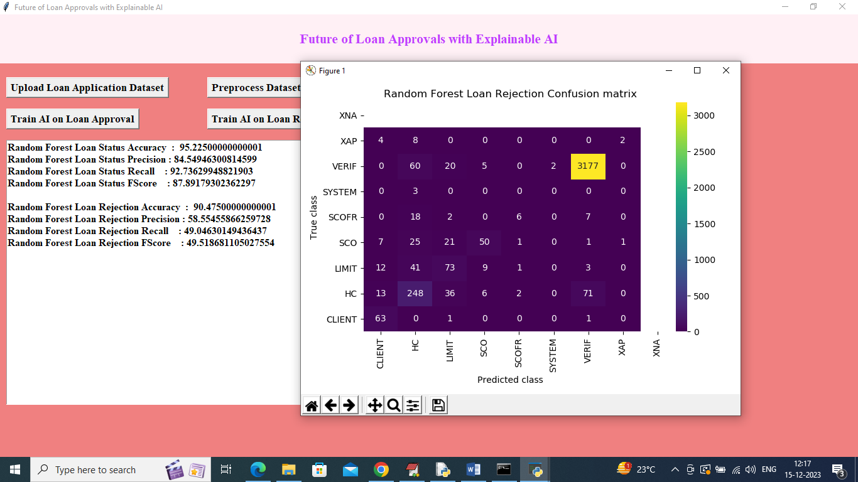

Fig 4.7: Train AI on Rejection Reason

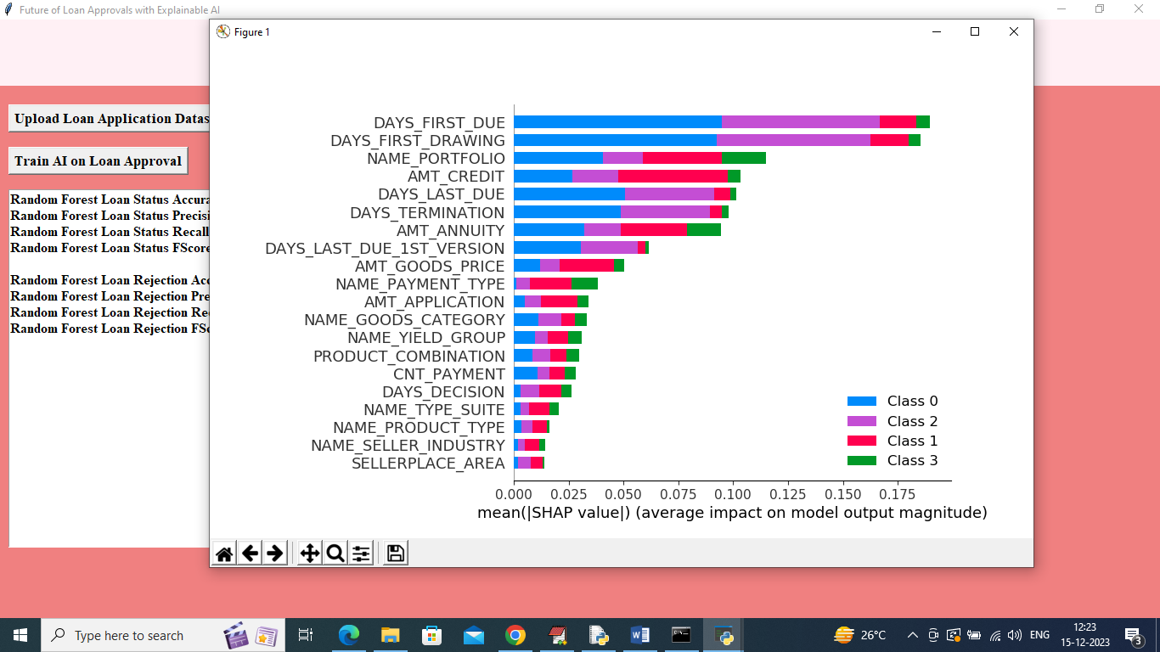

Fig 4.8: Explainable AI Feature Contribution

CMRCET CSE(AI&ML) Page No 23

Future of Loan Approvals with Explainable AI

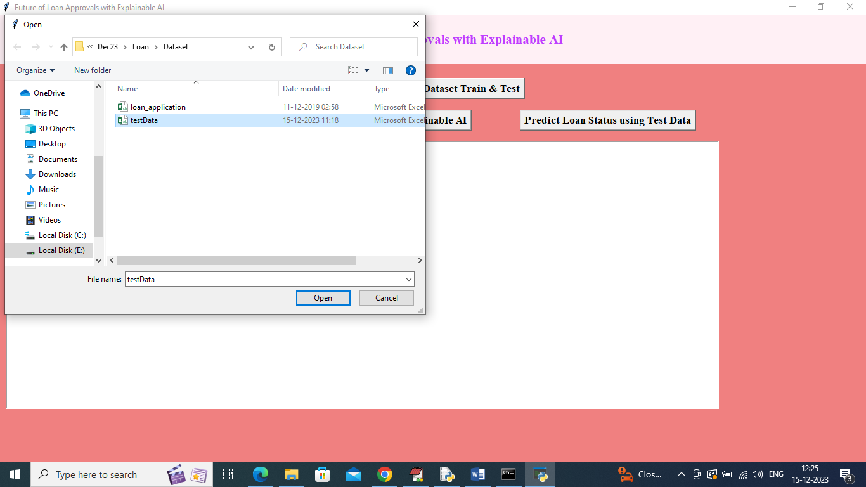

Fig 4.9: Predict Loan Status Using Test Data

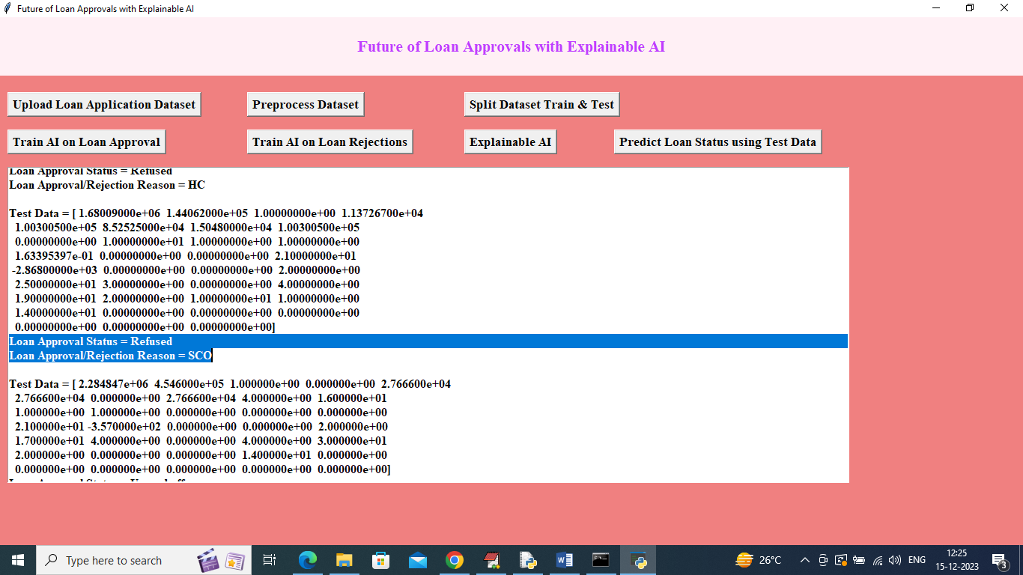

Fig 4.10: Test File Uploaded and Prediction Output

CMRCET CSE(AI&ML) Page No 24
Future of Loan Approvals with Explainable AI

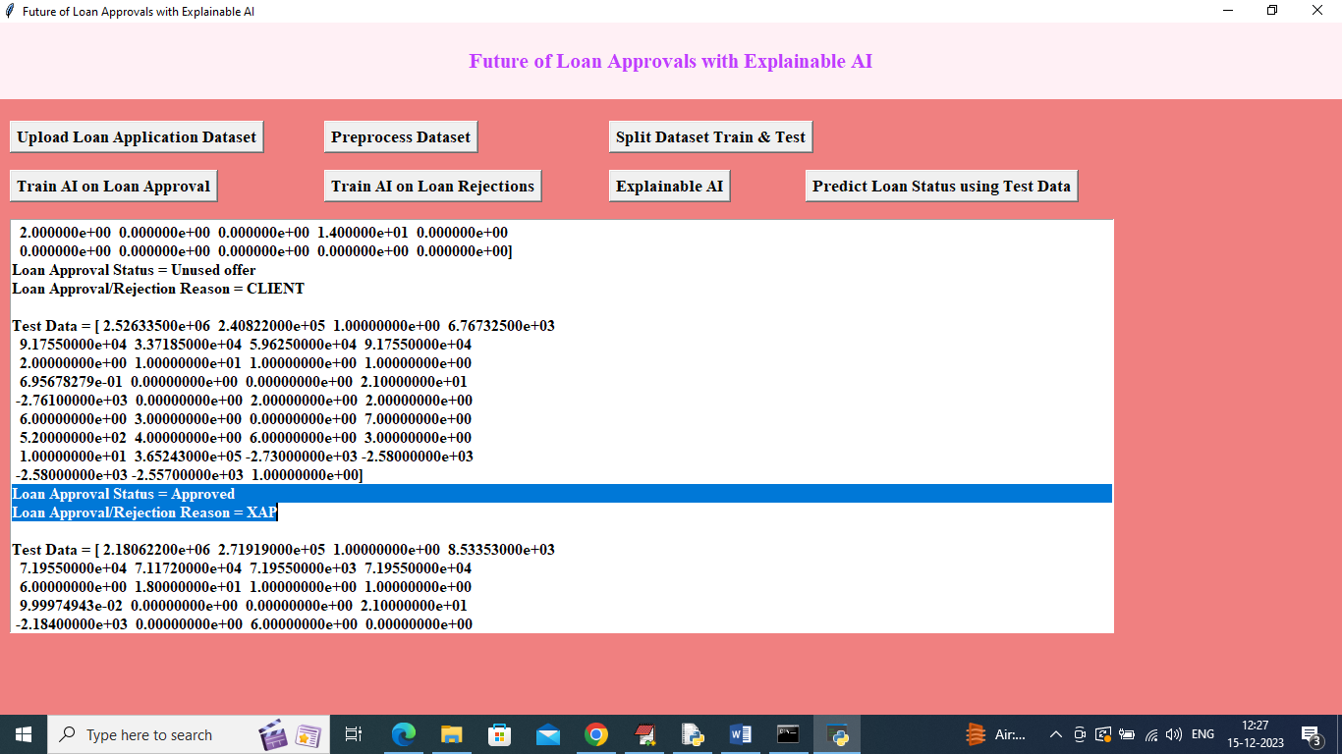

Fig 4.11: Predicted Loan Status with REASON

CMRCET CSE(AI&ML) Page No 25
Future of Loan Approvals with Explainable AI

CHAPTER 5
CONCLUSION

CMRCET CSE(AI&ML) Page No 26
Future of Loan Approvals with Explainable AI

CHAPTER 5
CONCLUSION

In conclusion, the "Future of Loan Approvals with Explainable AI" project envisions a future where loan approval decisions are not only accurate but also transparent and understandable. By embracing Explainable AI, the project aims to set new standards for fairness, accountability, and trust in the loan approval process.

CMRCET CSE(AI&ML) Page No 27
Future of Loan Approvals with Explainable AI

REFERENCES

CMRCET CSE(AI&ML) Page No 28
Future of Loan Approvals with Explainable AI

REFERENCES
- Smith, J. "Challenges in Transparent Loan Approval: A Review of Existing Systems and Limitations."
- Johnson, E. "Explainable AI in Finance: Enhancing Transparency and Trust in Loan Approvals."
- Brown, M. "Fairness-Aware Machine Learning for Bias Mitigation in Loan Approval Systems."
- Davis, S. "Interpretable Dashboards for Loan Approval: Design Principles and User Experience."
- White, D. "Dynamic Learning in AI Models for Loan Approvals: Adapting to Changing Economic Conditions."

CMRCET CSE(AI&ML) Page No 29
Future of Loan Approvals with Explainable AI

CONFERENCE/
JOURNAL PUBLICATION

CMRCET CSE(AIML) Page No 30

Future of Loan Approvals with Explainable AI

GitHub Link
1. https://github.com/aakash/Future of Loan Approvals with Explainable AI.git.

CMRCET CSE(AIML) Page No 31

